Getting Ready to Breastfeed

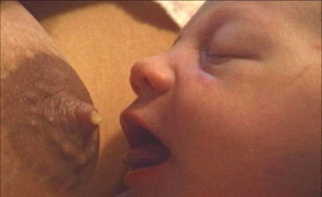
Breastfeeding begins before birth
Colostrum, baby’s first milk, starts to develop in your breasts after 16 weeks of pregnancy. A baby only needs very small amounts of this milk when they are born and in the first few days of life.
There are important steps to take to help prepare yourself to breastfeed baby.

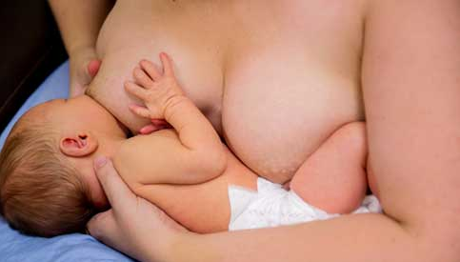
Gather Your Support Team
A support team can consist of:
- Family members
- Friends who have breastfed
- Obstetrician/Midwife
- Pediatrician
- Lactation Consultant – available free through AHS Public Health Breastfeeding Clinic
- Local Public Health Nurse
- Peer Support Groups – La Leche League online. www.lllc.ca/virtual-meetings-calendar
It is important to choose a team that supports your goals in feeding your baby.
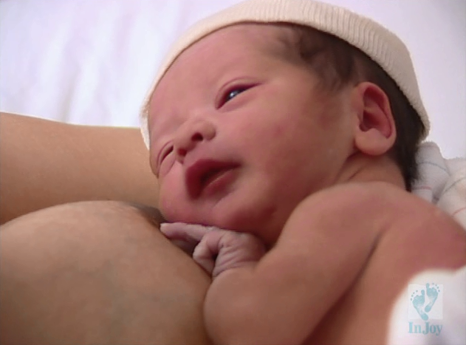
Learn About Breastfeeding
It is important to know before delivery some of the information that can help you get started out right. Information can be found through
- Books – Healthy Parents Healthy Children Pregnancy & Birth.
Free copies available at your Public Health office.
- Online resources – healthyparentshealthychildren.ca
Provides breastfeeding basics
- Attend a free, online AHS Breastfeeding Class – Contact AHS
Fort McMurray Public Health to learn more
- Learn to safely collect your colostrum prior to delivery
- contact AHS Public Health for more information
- Ask an AHS Public Health nurse about things you have heard.

Fort McMurray Public Health – 113 Thickwood Blvd. (780)791-6247

Helpful Steps to Success

- Hold your baby skin to skin right after birth and until the first feed.
- Delay common procedures until the first feeding is done (weight, injections) unless medically necessary.
- Keep baby in your room with you at all times while in the hospital. This will help you to recognize baby’s feeding cues and respond to them.
- Feed your baby at least eight times in 24hours, watch for feeding cues.
- No visitors during hospital stay other than immediate support person – it is your time to get to know your baby and learn.
- Do not use pacifiers, offer your breast if babe is fussy.
- No supplemental bottle feedings unless medically indicated. Baby can also be fed expressed breastmilk with a cup, spoon or syringe if needed.
- Do not accept free samples of formula that may distract from your breastfeeding goals.

Contact Fort McMurray AHS Public Health
at 780-791-6247 for further questions or concerns.

